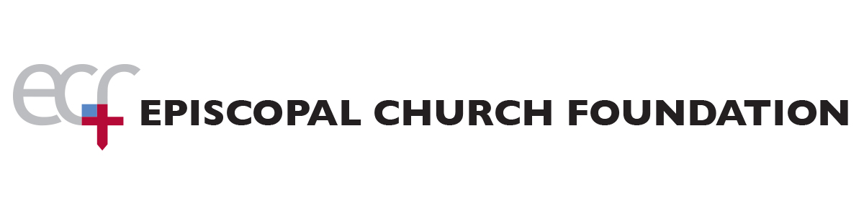
Workshops on Planned Giving for Parish Leaders
Saturday – May 19, 2018 – 9am - Noon

Church of the Epiphany
3285 Buffalo Rd, Rochester, NY 14624

Parishes with or without an existing Planned Giving ministry and/or an Endowment will benefit from these workshops. These workshops will review best practices and empower leadership to take the next best steps for their parish!

Setting Up a Planned Giving Program for Your Parish 9 am – 10 am
Take the mystery out of planned giving for your parish. Learn in easy to understand terms how planned giving differs from annual stewardship and capital campaigns, and how your parish can build endowments through wills and life income and other planned gifts. After a review of the planned giving instruments, you will learn about the importance of a parish vision and how to invite others to remember your parish through estate and financial planning.

Importance of Endowment Structure 10 am – 11 am
Every church, no matter how large or how small, deserves to have a well-structured endowment in place. Endowments breathe life into a congregation. They make new ministries possible, spark creative outreach projects, ease the burden of long-term capital expenses, and secure the future of our churches. From the donor’s perspective, a well-ordered endowment provides a trustworthy means of making a legacy gift.

Using ECF Resources and Planning a Legacy Society for Your Parish 11 am – Noon
Join us to learn how to use the resources provided by ECF’s new toolkit, Planned Giving on Demand and other resources to encourage new gifts to support your parish’s future through estate and financial planning. We will also review how to create and sustain a Legacy Society to encourage giving to your parish for decades to come. You will leave the workshop with a plan of action.

You can register for the May 19th workshop on the Diocesan website or by contacting Kristy Estey via email kristy@episcopaldioceseofrochester.org or calling (585) 473-2977 option 3 by Monday, May 14th.

