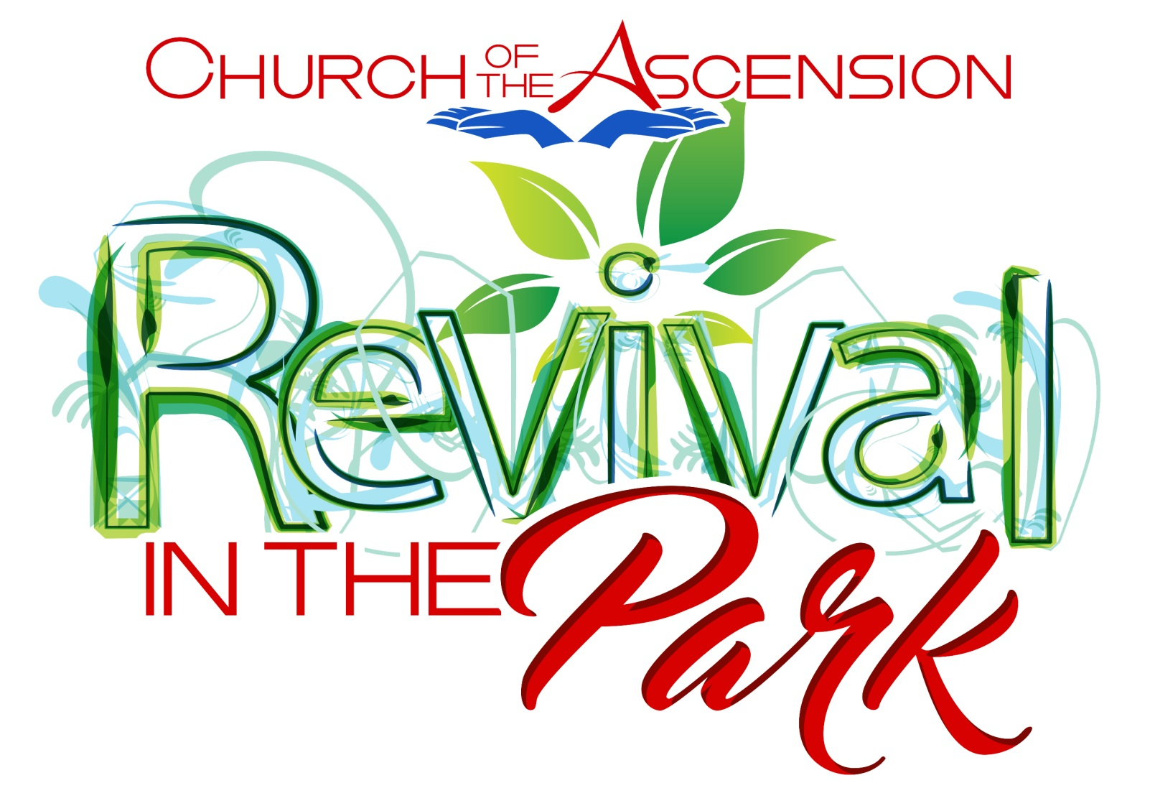

Your friends at Church of the Ascension cordially invite you and your family & friends to:
Ascension’s Revival in the Park
Friday October 5, 2018—4-8 PM
Saturday October 6, 2018—10 AM—8 PM

Durand Eastman Park
Camp Eastman
Spies Conference Center
(Available on Google Maps)

Event is free. Food truck/s available to purchase meals

We will share great preaching, great music, great food, great fun—children’s activities— Saturday afternoon

Come celebrate God’s love!

Your friends at Church of the Ascension cordially invite you and your family & friends to:
Ascension’s Revival in the Park
Friday August 23, 2019—4-8 PM
Saturday August 24, 2019—2-8 PM

Seneca Park
2222 St. Paul Street, Rochester, NY 14621
Wegman Building
(Available on Google Maps)

Event is free. Food truck/s available to purchase meals

We will share great preaching, great music, great food, great fun—children’s activities— Saturday afternoon
Come celebrate God’s love!

