PILGRIMAGE to the HOLY LAND April 30 – May 12th, 2017

The Episcopal Diocese of Rochester and the Rev. Lynne Sharp present an exceptional opportunity to join in a pilgrimage to the Land of the Holy One, visiting the places of the birth, life, ministry, death, and resurrection of Jesus, as well as Jewish and Muslim holy sites, and a fascinating and informative encounter with the present-day cultures and challenges of Israel-Palestine.
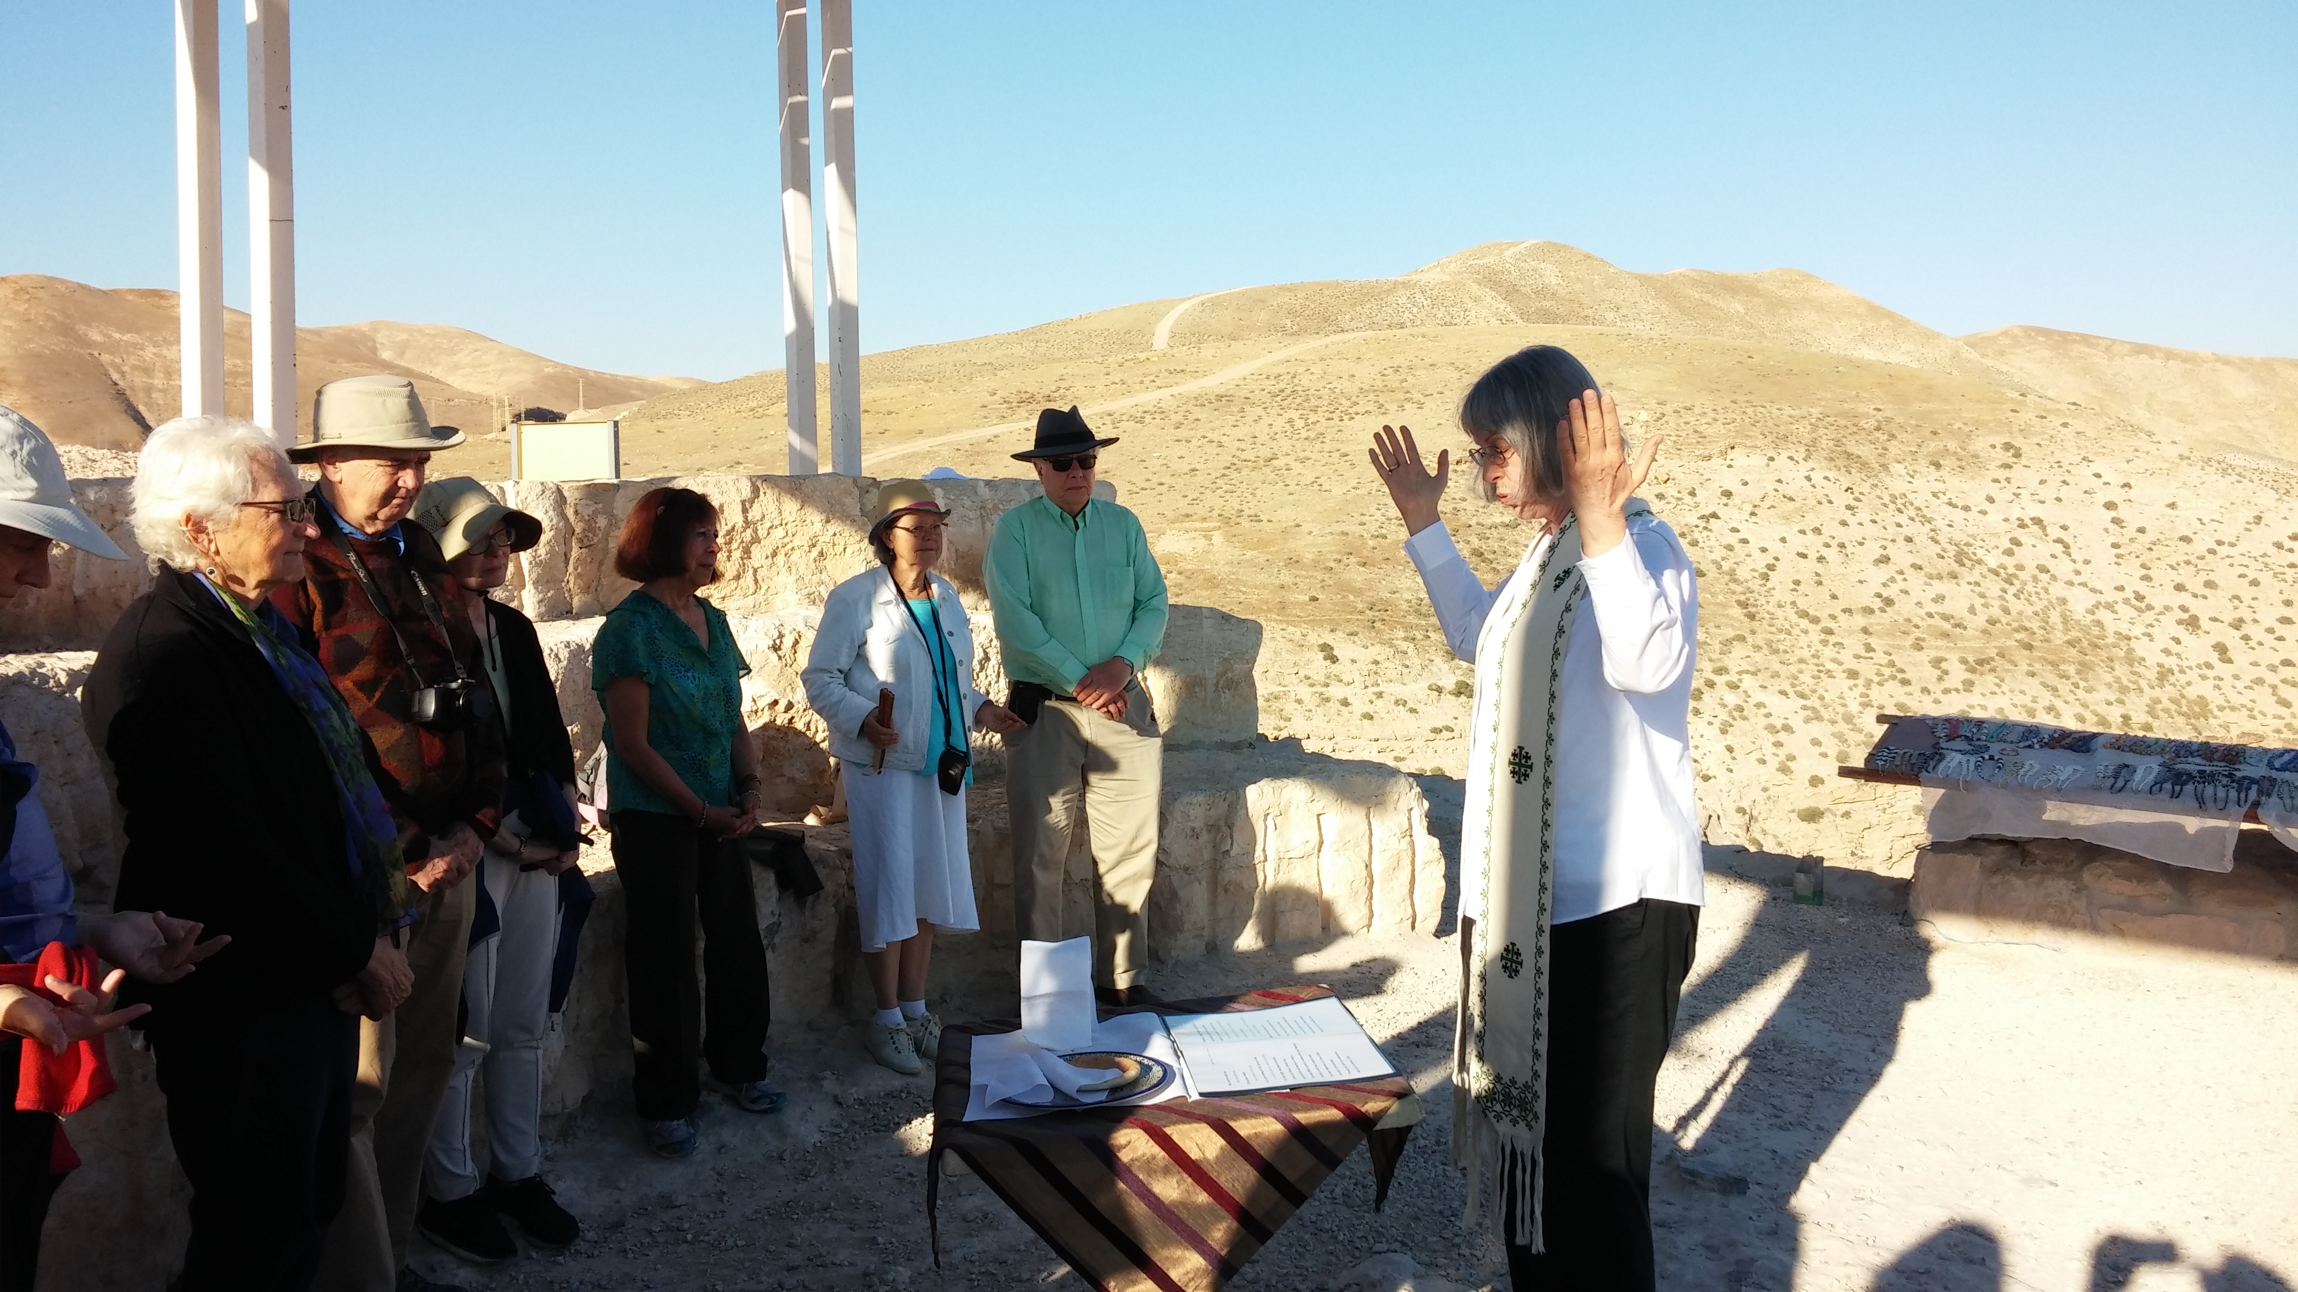
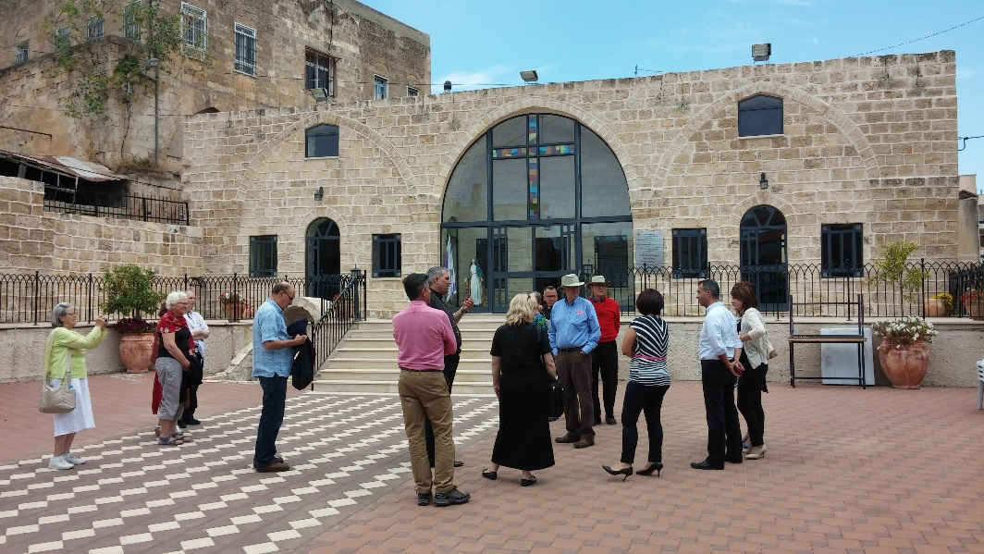
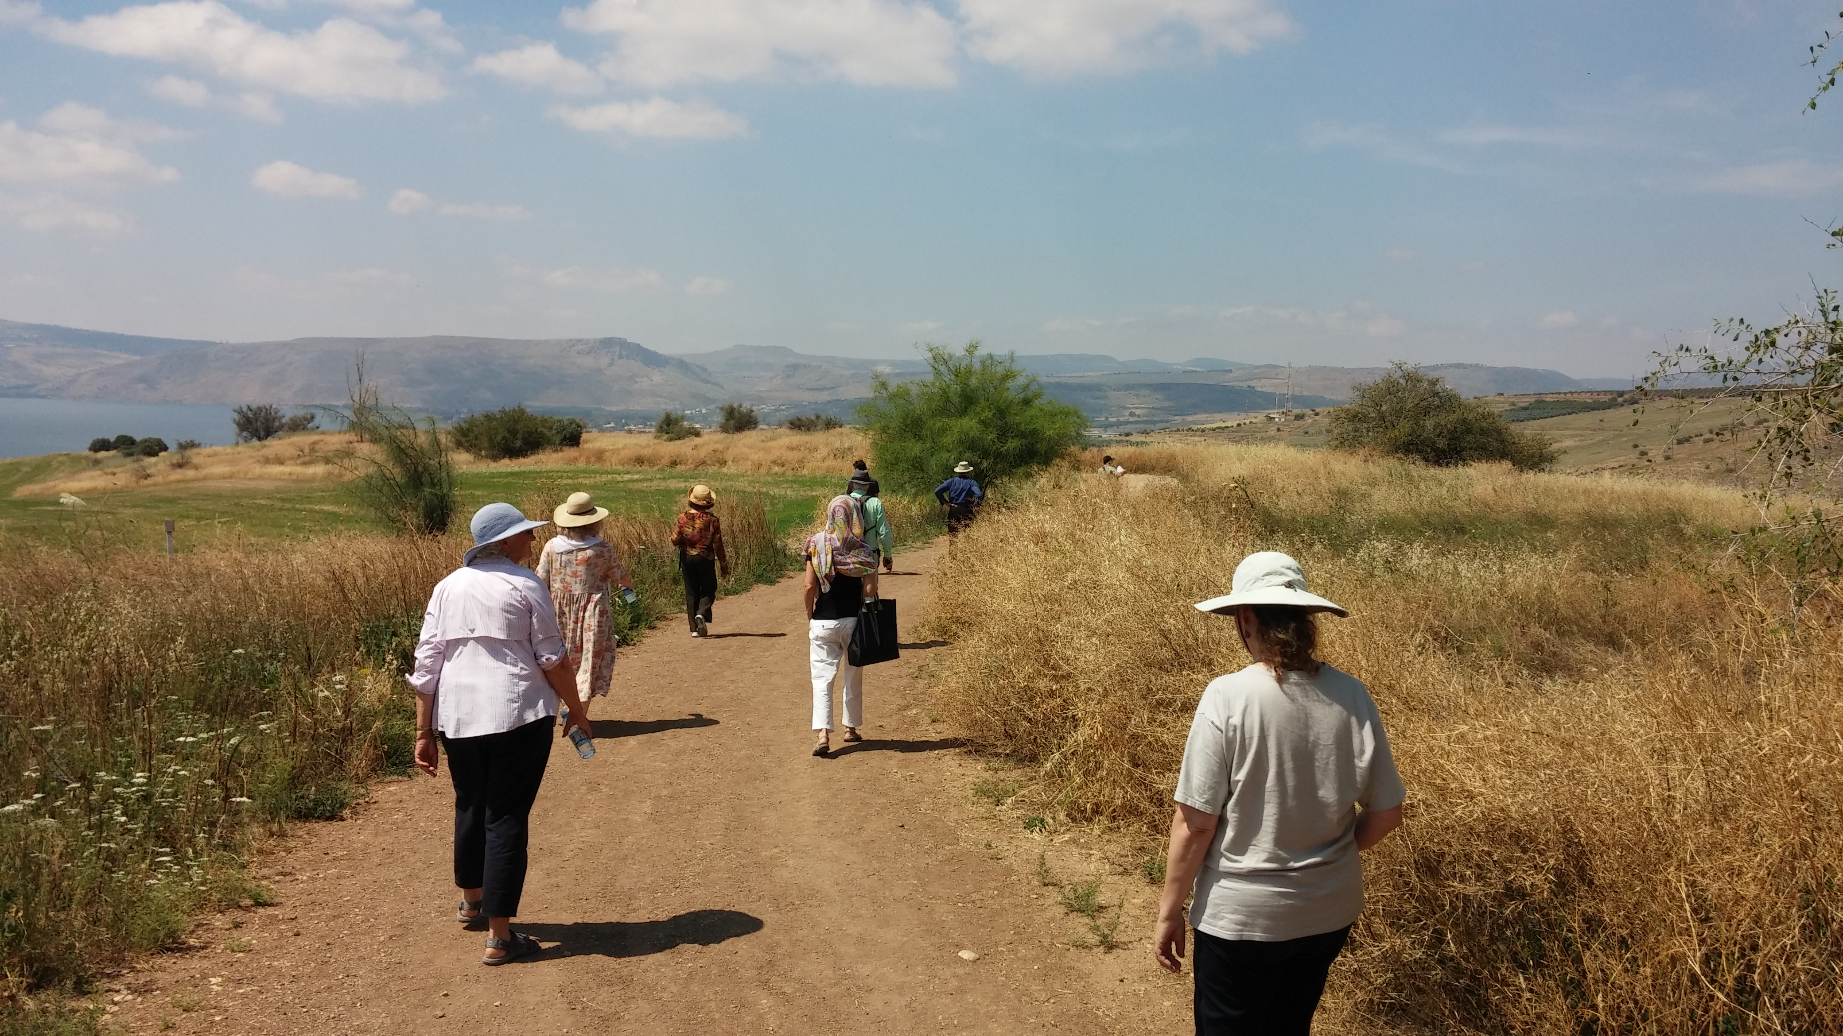

Not your cookie-cutter commercial tour

Over the past 20 years, Iyad Qumri has developed a unique and personalized way of sharing the biblical, cultural, social, and political riches of the Holy Land with pilgrims from all over the world. In more recent years, Iyad’s focus has been on particular service to pilgrims coming from the Episcopal Church, including over a dozen bishops and scores of parishes and cathedrals. Besides the important places one would expect to visit, we try to find off-the-beaten-path, special experiences to deepen appreciation of both the scriptures and the contemporary local cultures.  Is it safe to travel to the Holy Land? Yes, yes, yes. We’ve had wonderful experiences with pilgrim groups and uninterrupted schedules throughout the summer of 2014 (see “Iyad Qumri Pilgrimages” on Facebook). Our local hosts want us to have a safe, inspiring, informative, and pleasurable stay. Middle East hospitality (and food!) are unforgettable.  12 days, $2040, per person double occupancy  AIRFARE NOT INCLUDED, SOME SINGLE ROOMS AVAILABLE, ADD $650. | Pilgrimage highlights  - Clean, quiet, comfortable pilgrim guest accommodations, each room with private bath and shower  - Pray the scriptures where key biblical events are commemorated: Nazareth, Bethlehem, Capernaum, Sea of Galilee, Jericho, the Dead Sea, and Jerusalem.  - Meet the “living stones” of the ever-diminishing communities of the local Christians, including an introduction to the vital ministries of the Episcopal Diocese of Jerusalem.  - Walk not only in the footsteps of Jesus but in those of two millennia of pilgrims.  To join or for more information:  contact Rev. Lynne Sharp  Rectorstjames14840@gmail.com

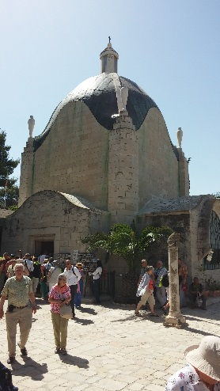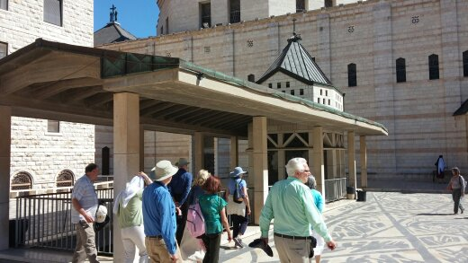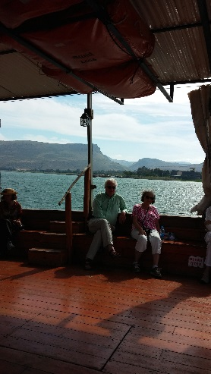

(above: pilgrims at the (above: Pilgrims passing the baptismal font at the Church of the (Above: Pilgrims on
“Dominus Flevit” Church Annunciation in Nazareth.) the Sea of Galilee.)
on the Mt. of Olives)

Our proposed itinerary begins with a welcome at Tel Aviv’s very modern Ben Gurion International Airport and then coach transportation up to Jerusalem. Our Jerusalem home will be St. George’s Pilgrim Guest House, located on the close with St. George’s Cathedral and the diocesan offices, St George’s School, and St. George’s College. Our wonderful facility includes a beautiful enclosed garden and patio, excellent food, comfortable rooms, and an easy stroll to shops, ATM, and the historic Old City of Jerusalem.  Our first day will include a tour of the cathedral, of our friendly and lively neighborhood, and of the Christian Quarter of the Old City, | including the Church of the Holy Sepulchre. Evenings in Jerusalem will include local guests to engage in dialogue from Jewish, Muslim, and Palestinian Christian perspectives. In the next days we will visit sites holy to Jews and to Muslims, the Western Wall and the Elharam Esh Sharif (Dome of the Rock and Al-Aqsa Mosque). Nearby we explore the beautiful St. Anne’s Church and the ruins of the Pools of Bethseda.  Near Jerusalem we journey to Bethlehem and the Shepherds’ Fields. Also nearby are ancient and modern Jericho, with a cable-car ride and a short hike to the desert monastery of the Mount of Temptation. | A three-night Galilee stay in the heart of Nazareth at the wonderful Sisters of Nazareth includes the churches of the Annunciation, a day around the sea of Galilee to see ancient Capernaum, walk the beautiful hillside of the Beatitudes, pray where healings and miraculous feedings took place, and a boat ride.  Before returning to Jerusalem for the climactic Palm Sunday Walk and the Via Dolorosa, we visit the ancient church at Burquin, Jacob’s Well in Nablus, and Taybeh; Palestine’s last all-Christian village.
 | Canon Iyad Qumri is a local Arab Palestinian Christian guide, licensed by the Israeli Ministry of Tourism. Iyad has a wealth of historical, biblical, and contemporary cultural knowledge and enthusiasm (and unique humor) to share.
The Rev. Lynne Sharp, a parish priest in the Diocese of Rochester, made her first Pilgrimage to the Holy Land in 2015, and knew she needed to return with a group. Lynne will assist in the group’s spiritual care and leadership.
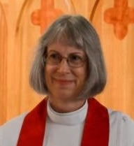

JOIN US FOR THIS MEMORABLE ADVENTURE IN FAITH AND LEARNING.

